**Testing 1 for T056:**

**S1:   Clientele**

|  |  |  |  |
| --- | --- | --- | --- |
| **Task ID** | **Task Description** | **Estimate** | **Done** |
| **T056** | Filter email input to except only “ @connect.qut.edu.au” | 1.5 | heck mark symbol |
| **T057** | Write tests. | 1.5 | heck mark symbol |
| **T058** | Show an alert box if none qut email is entered. | 1.5 | heck mark symbol |
| **T059** | Verify story is complete with acceptance test. | 1.5 | heck mark symbol |
|  | **Story Points                                                                              Total Hours** | **2**  **6** | |

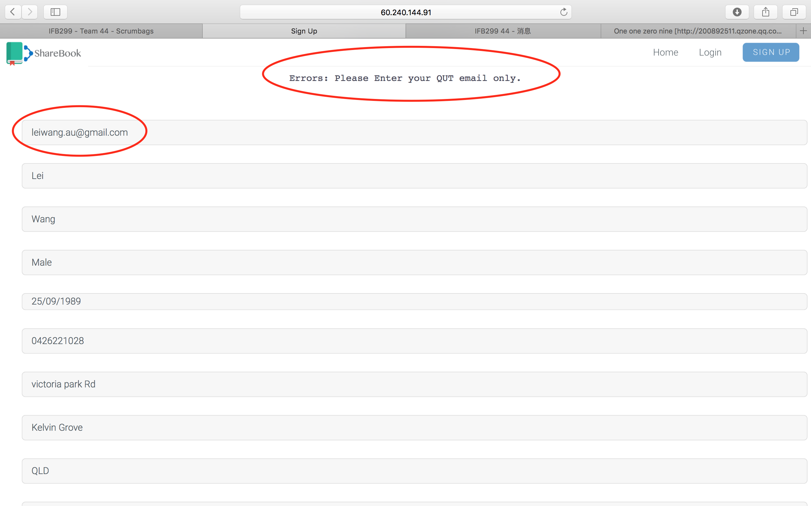

Acceptance check: If we not use “@connect.qut.edu.au”, it will show Errors message “Please Enter your QUT email only”.

**Testing 2 for S51**

**S51:   Password Strength**

|  |  |  |  |
| --- | --- | --- | --- |
| **Task ID** | **Task Description** | **Estimate** | **Done** |
| **T045** | Test Password has at least 6 characters. | 1 | heck mark symbol |
| **T046** | Test Password contain an uppercase letter, symbol and number | 1 | heck mark symbol |
| **T047** | Categories the inserted password to : Strong, medium and weak. | 1 | heck mark symbol |
| **T048** | Create a span message to show the password strength. | 1 | heck mark symbol |
| **T049** | Write test scripts. | 1 | heck mark symbol |
| **T050** | Verify story is complete with acceptance test | 1 | heck mark symbol |
|  | **Story Points                                                                      Total Hours** | **2**  **6** | |

**T045:**

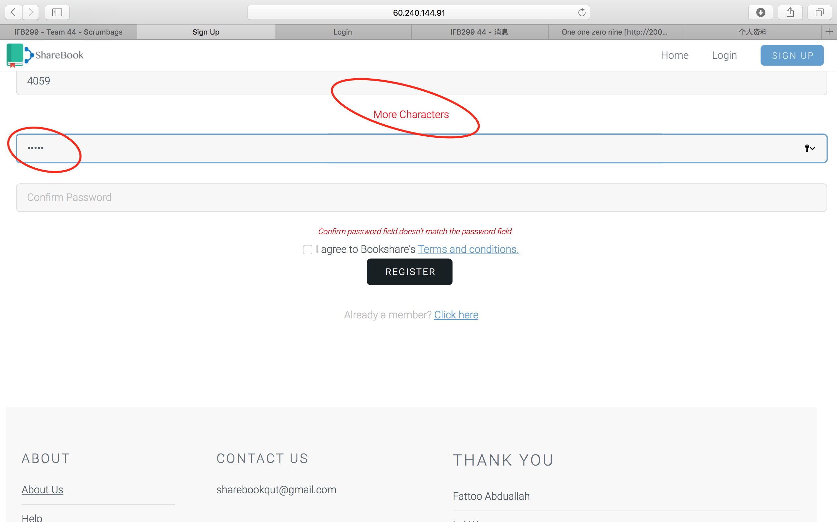

Acceptance check: If we enter less than 6 characters, it will show “ More Characters”.

T047:

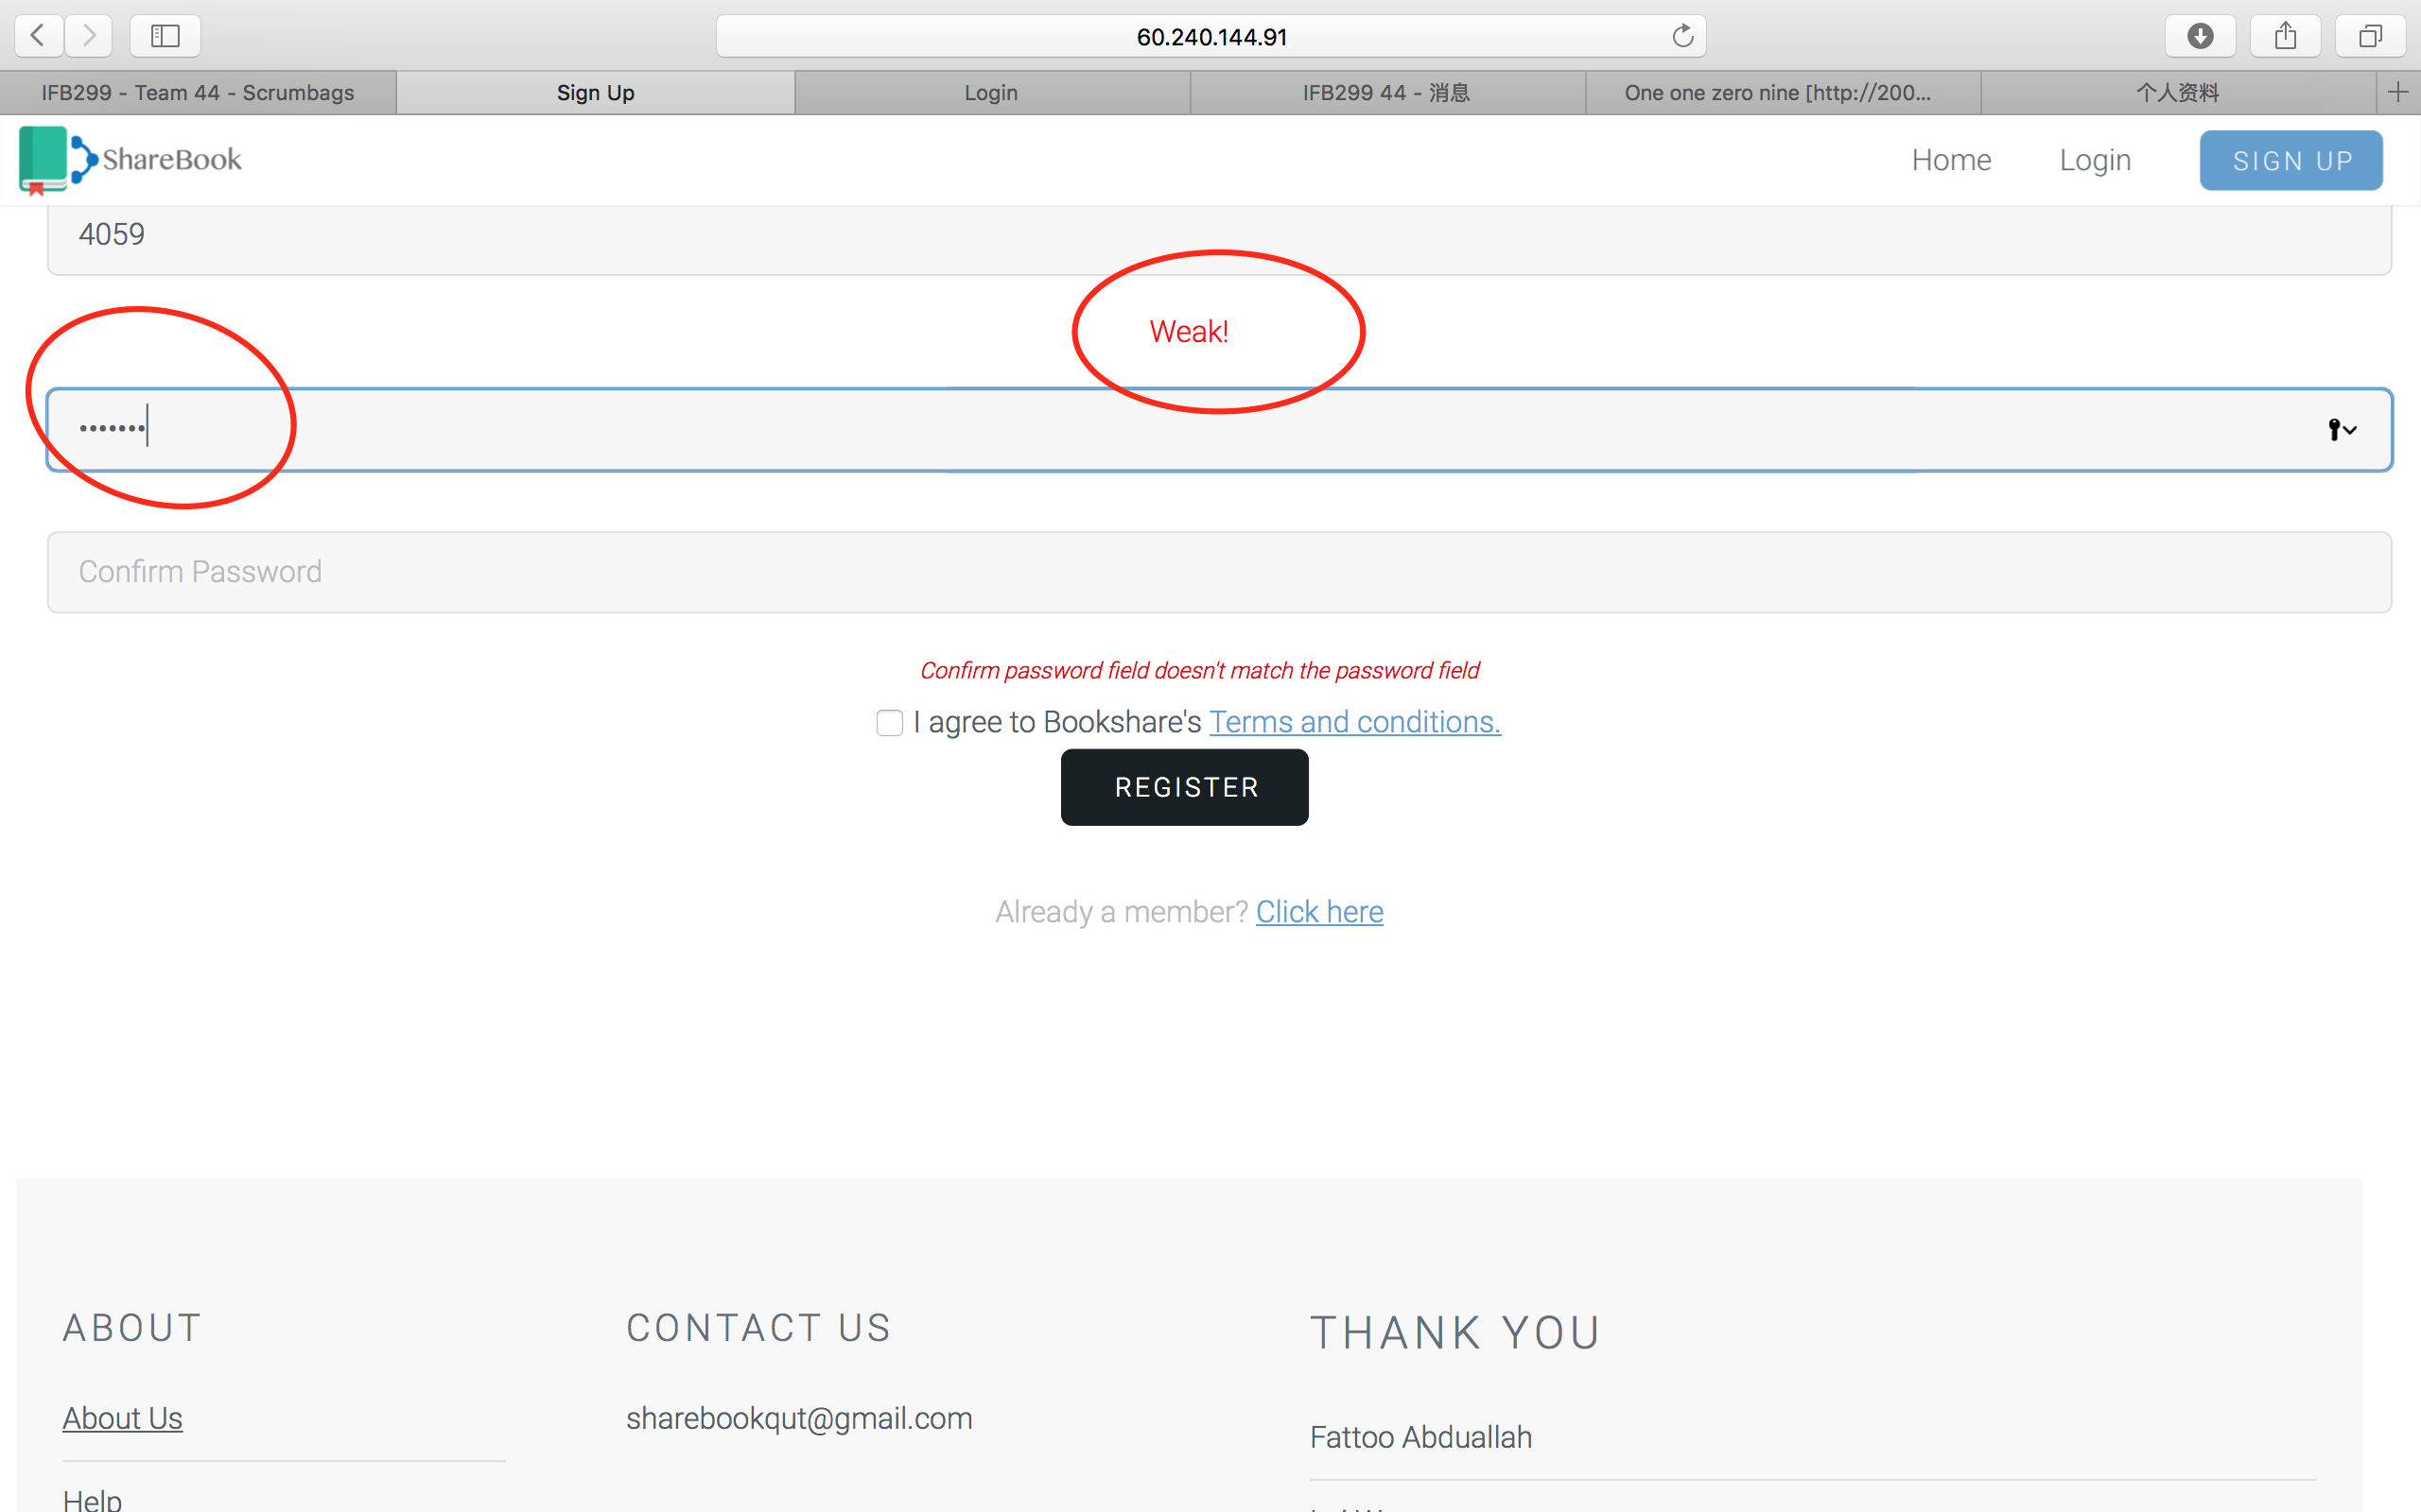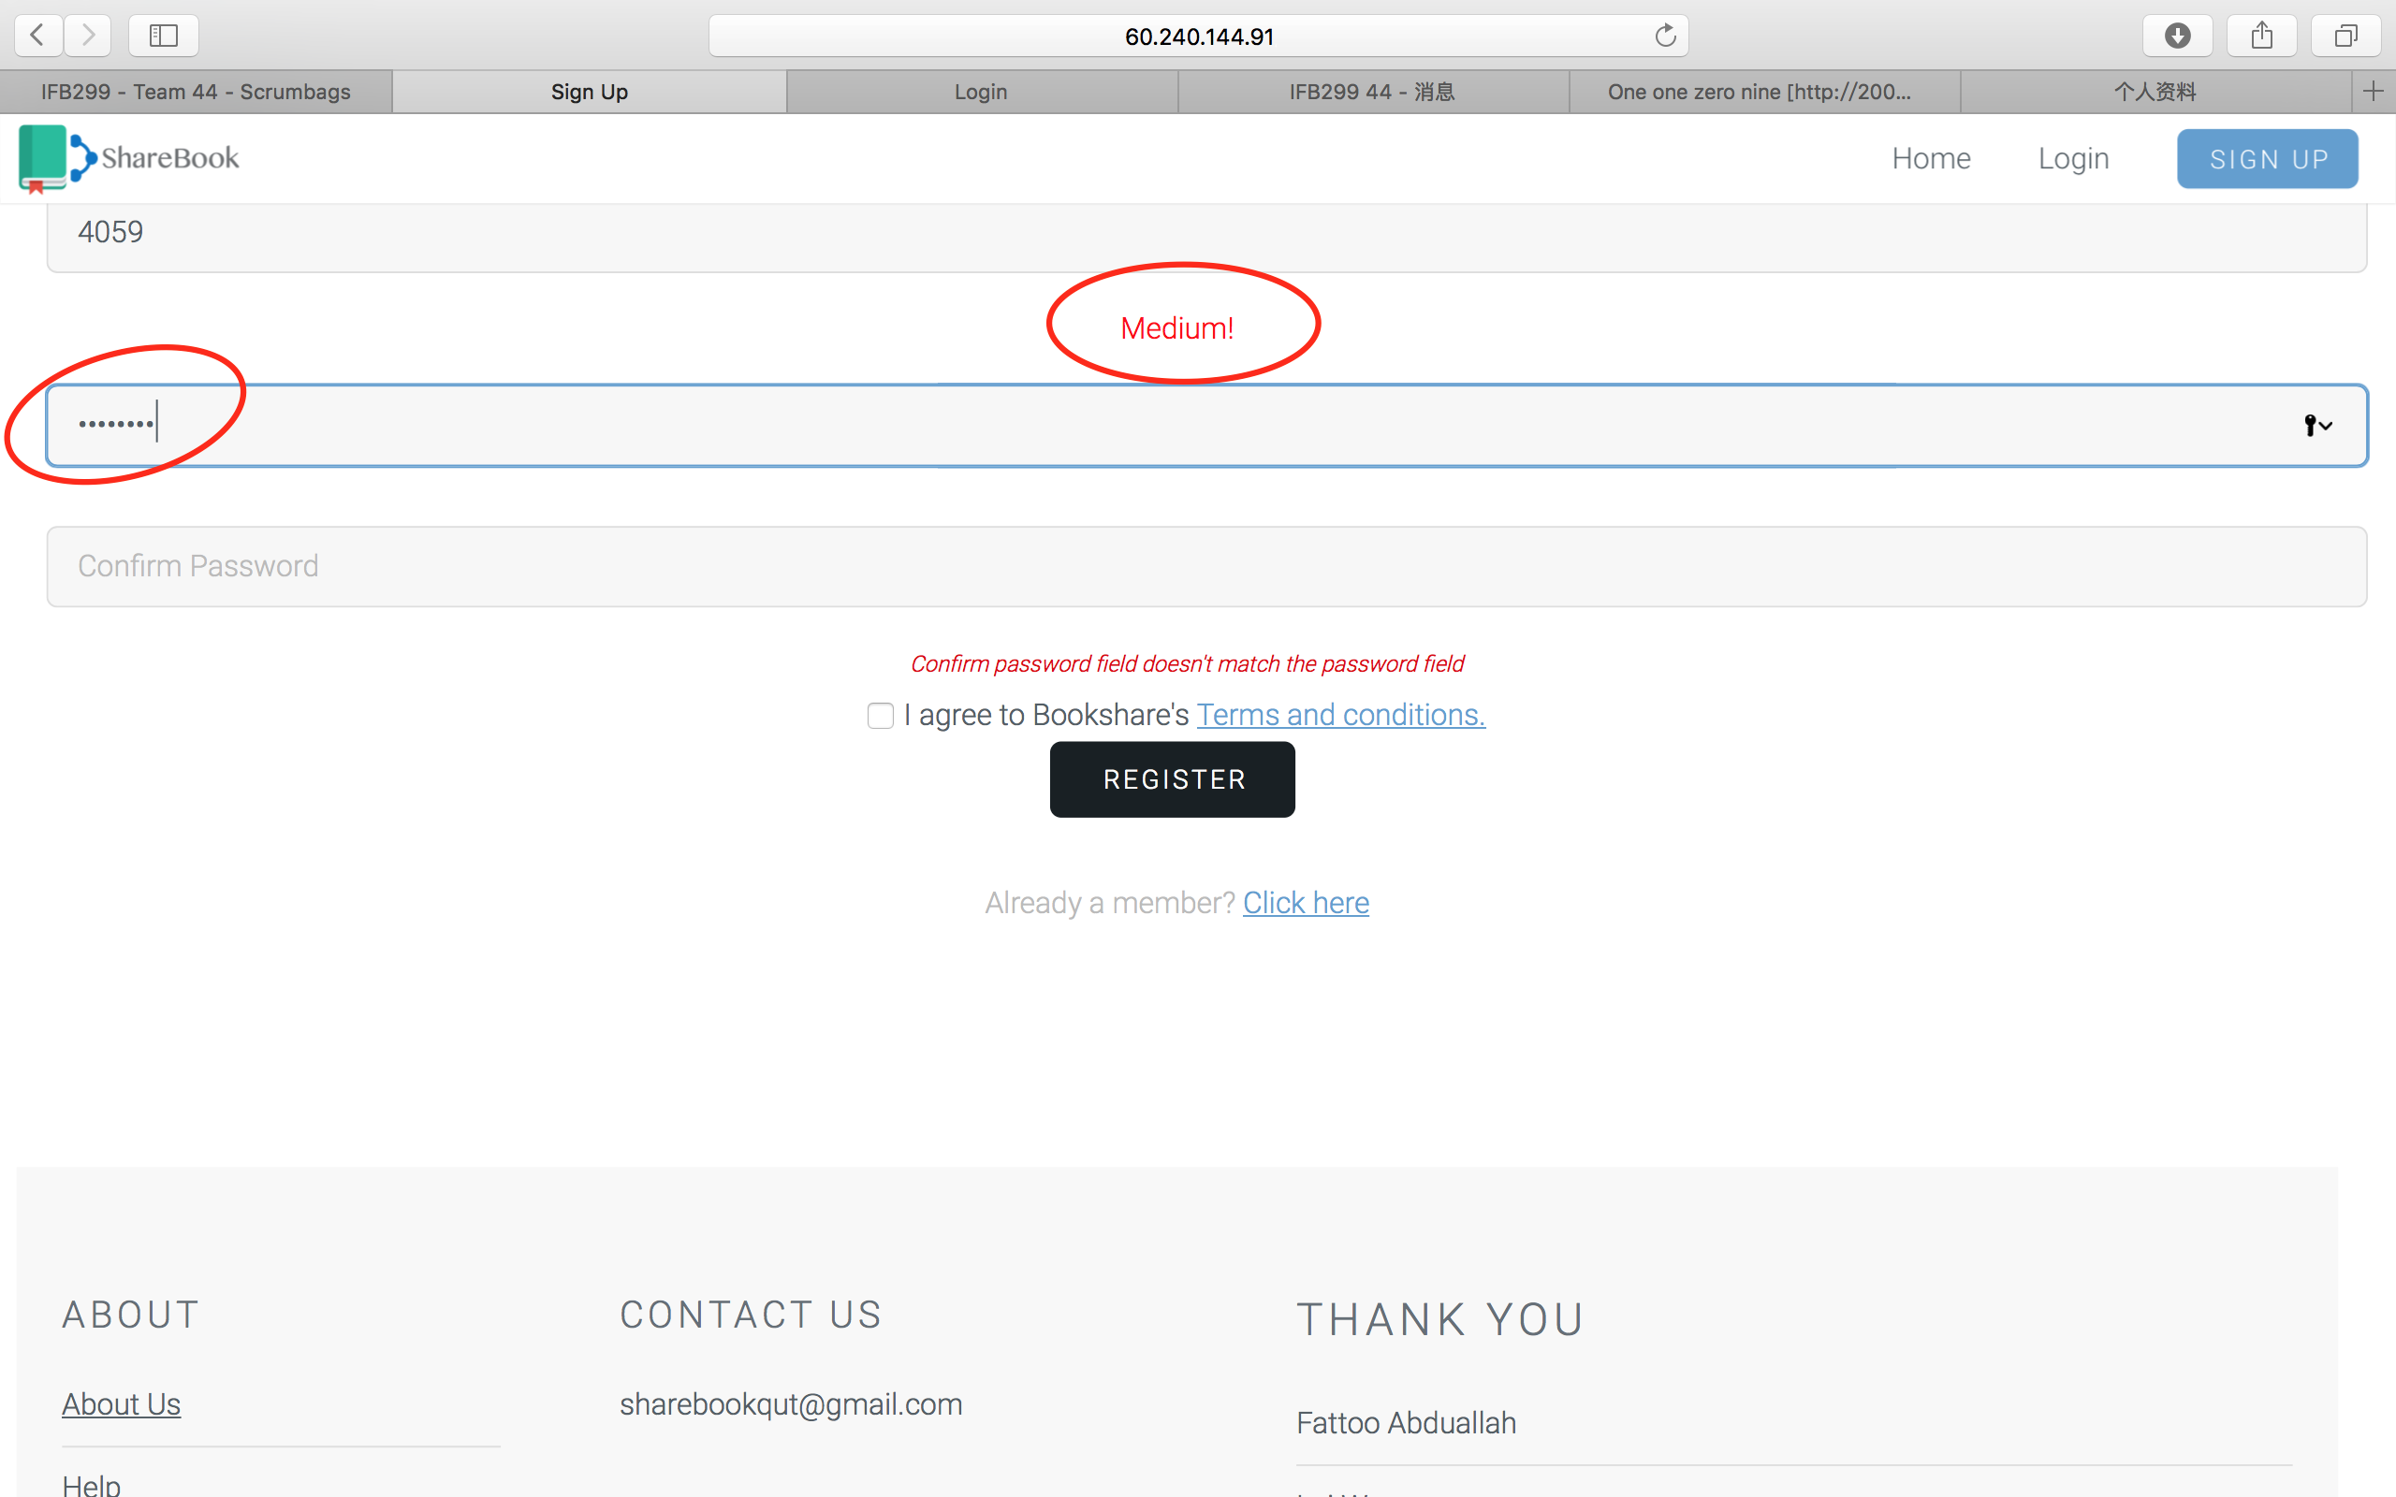

**For Confirm password:**

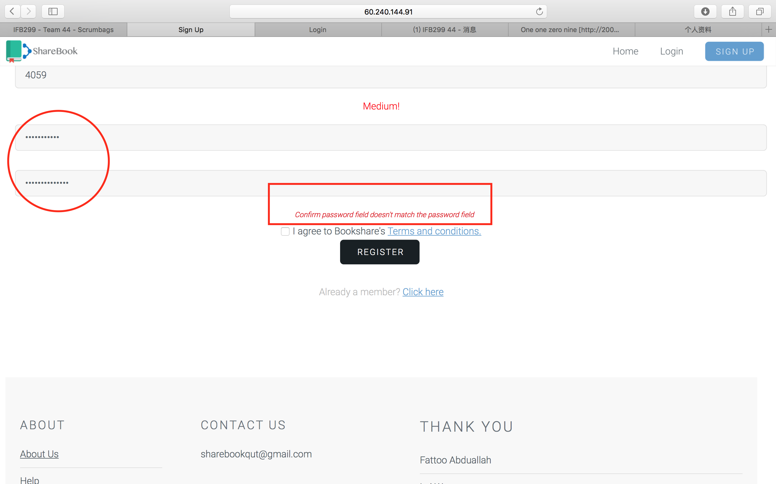

Acceptance check: If the password are different, it will be show “Confirm password field doesn’t match the password field”

**Testing 3 for S10:**

**S10:   Sort by book name**

|  |  |  |  |
| --- | --- | --- | --- |
| **Task ID** | **Task Description** | **Estimate** | **Done** |
| **T84** | Write codes to sort by name. | 2 | heck mark symbol |
| **T85** | Retrieve result from the database by name order. | 2 | heck mark symbol |
| **T86** | Write tests. | 1 | heck mark symbol |
| **T87** | Verify story is complete with acceptance test. | 1 | heck mark symbol |
|  | **Story Points                                                                              Total Hours** | **2**  **6** | |

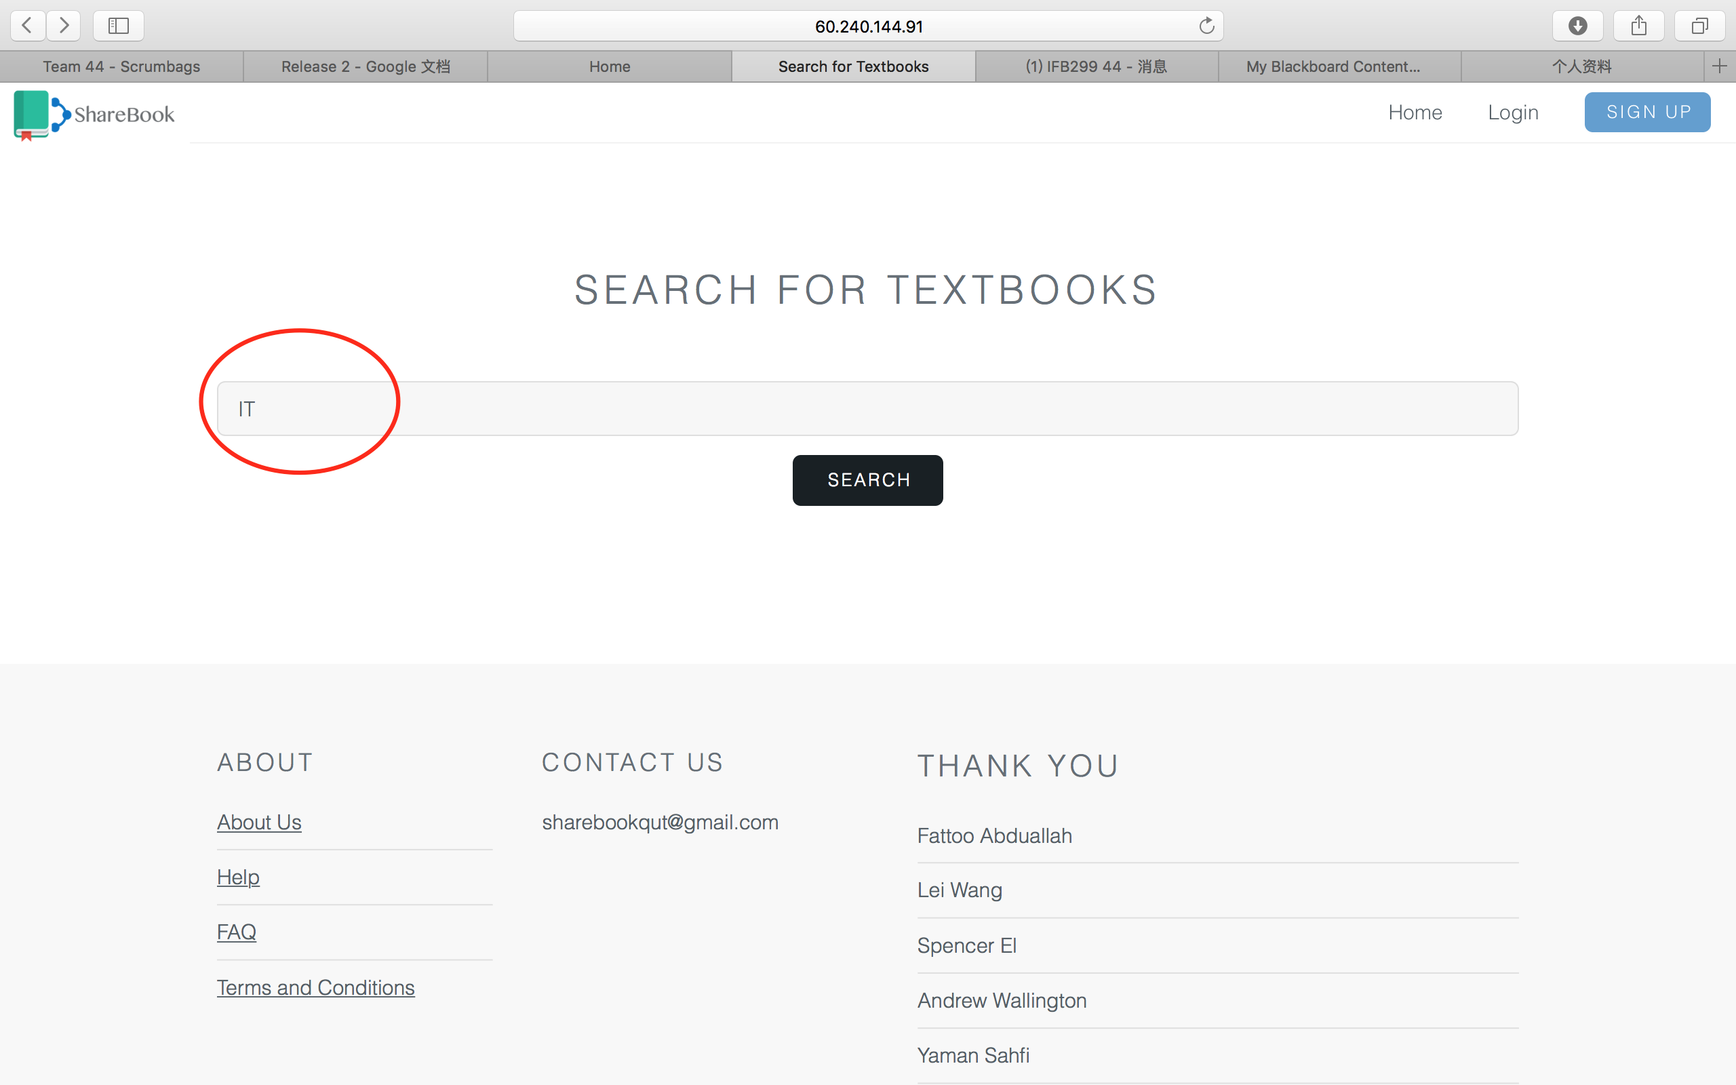

Acceptance check:

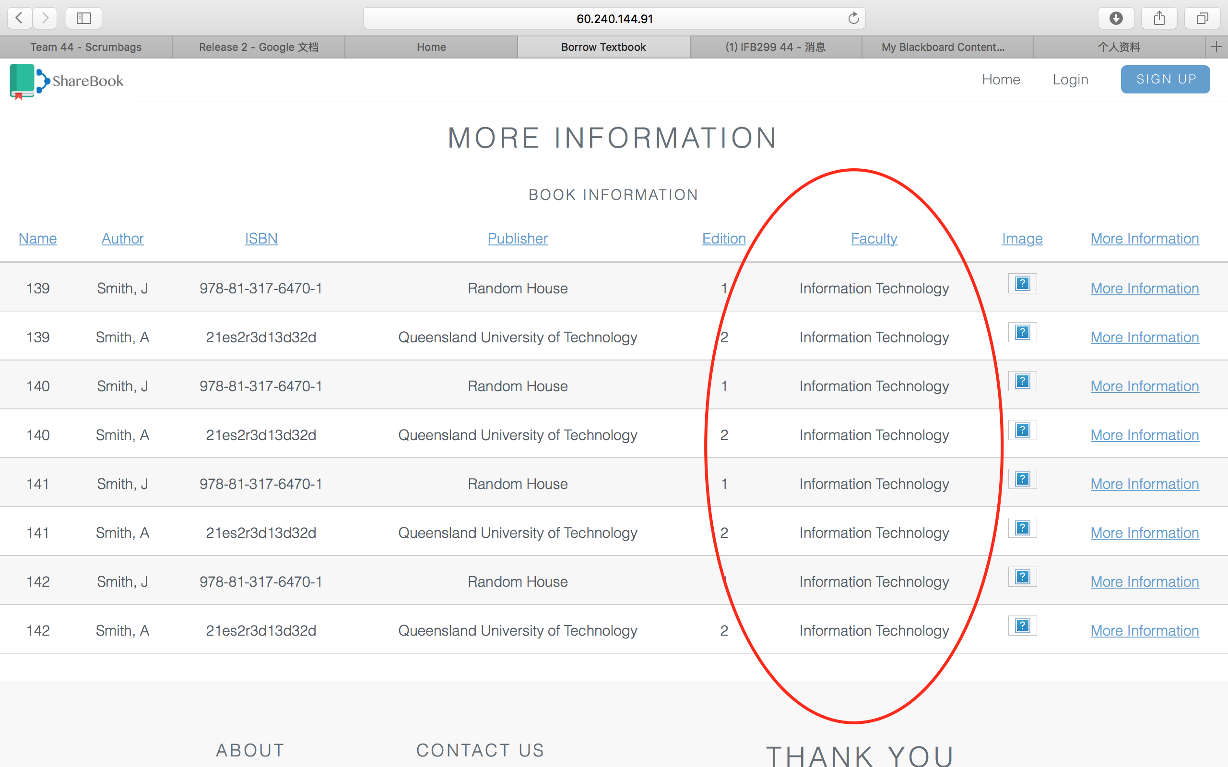

**Testing 4 for S11:**

**S11:   Sort by author**

|  |  |  |  |
| --- | --- | --- | --- |
| **Task ID** | **Task Description** | **Estimate** | **Done** |
| **T88** | Write codes to sort by Author. | 2 | heck mark symbol |
| **T89** | Retrieve result from the database by Author order. | 2 | heck mark symbol |
| **T90** | Write tests. | 1 | heck mark symbol |
| **T91** | Verify story is complete with acceptance test. | 1 | heck mark symbol |
|  | **Story Points                                                                              Total Hours** | **2**  **6** | |

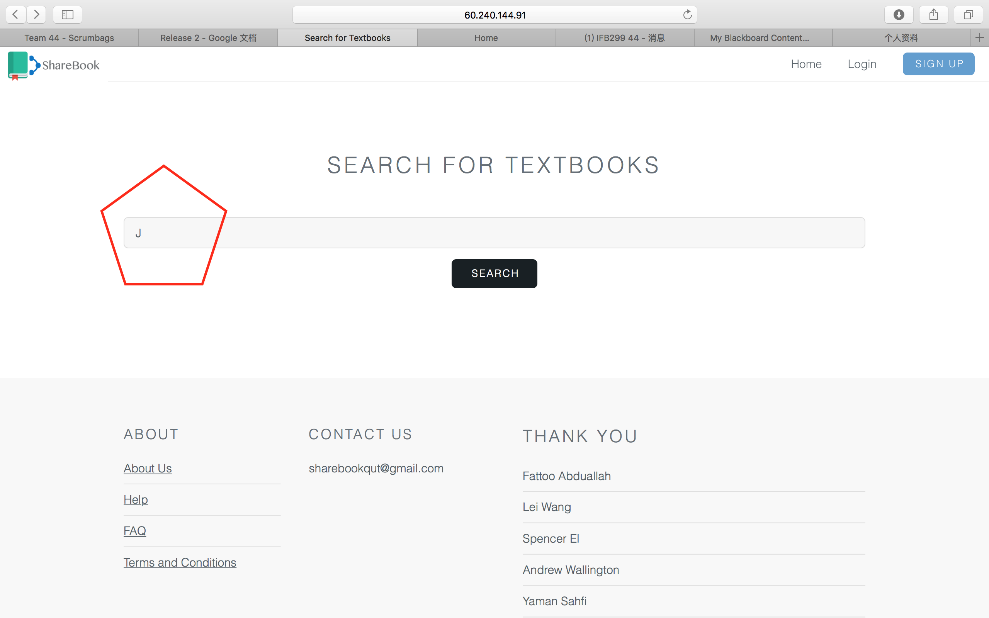

Acceptance check:

